Financial Economics Final Group Project

Kailu Wang, Zeng Yao

Modern Portfolio Theory or mean-variance analysis is a mathematical frame that assembles a portfolio of assets such that specific risk can be removed or at least mitigated and expected return is maximized through diversification of a portfolio. The diversification implies that investors should hold a combination of instruments that are not perfectly positively correlated and negative correlation are better (correlation coefficients range from -1 to 1). The theory assumes that investors are risk-averse, that investors always prefer the less risky portfolio at a certain level of expected returns. Hence, an investor who wants higher expected return has to accept more risk and investors would like to endure riskier assets only if compensated by higher expected returns. For example, stock investors who prefer risky assets could invest a small portion of their portfolios into sovereign bonds or securities which have negative correlation with stocks in order to reduce risk. The main idea of this theory is diversification; investing in various financial assets is less risky than owning just one type.

The modern asset portfolio theory is mainly aimed at the possibility of resolving investment risks. The theory believes that some risks have nothing to do with other securities, and diversification of investment targets can reduce individual risks, so the information of individual companies is less important. Individual risks are market risks, and there are generally two types of market risks, individual risks and systemic risks. The former refers to the risks surrounding individual companies and the uncertainty of the investment returns of a single company; the latter refers to the risks generated by the entire economy. It cannot be mitigated by diversified investment.

In my opinion, for the client, there is scope for applying the main idea of Modern Portfolio Theory to allocating their capital. From the results, it shows that,  
 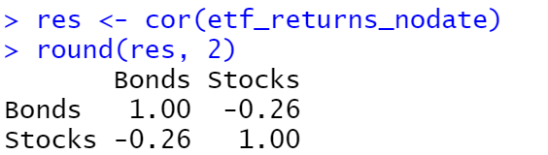

Since the correlation between the two assets are negative, then it is possible to apply the main idea of Modern Portfolio Theory to produce an asset that could reduce the risk.

I am going to test and compare the data from 1997/1/1 to 2021/5/31 as requested. Firstly, I just saw the first 6 weeks of the expected return of bonds and stocks. Then I compare the graphs of expected returns between bonds and stocks and there is a fluctuation difference between bonds and stocks that there are several severe fluctuations on stocks than on bonds. Also, when experiencing any economic crisis, stocks have sharper fluctuations hence, bonds perform better than stocks by just observing the graphs. Then look at the summary of the returns and we could find the mean returns of bonds is 0.000003296, and the mean returns of stocks is 0.0002826 which shows that the mean returns of stocks is much bigger than the bonds since it is riskier. What’s more, the standard deviation of bonds is 0.007219298 and for stocks is 0.01253943 and stocks have higher standard deviation than bonds which means the data from stocks are more dispersive relative to mean. Then look at the correlation coefficient between stocks and bonds which is -0.32 which shows that they are negatively correlated which means the combination of bonds and stocks could help investors reduce risks. Then we plug in expected return, standard deviation, correlation coefficient into Markowitz spreadsheet. The optimal risky portfolio shows that bonds weighted 0.46017, and stocks weighted 0.53983 and the expected return is 0.017% with risk and standard deviation 0.00652. The expected return from the combination is higher than the expected return of bonds, but lower than the expected return of stocks which is normal, since it is less riskier than both bonds and stocks. Hence the combination is pretty good.

Head of 6 returns:

Bonds Stocks

1997-01-03 0.001014713 0.014250032

1997-01-06 -0.002030458 -0.008777486

1997-01-07 -0.003053437 0.012101128

1997-01-08 -0.003062790 -0.008748233

1997-01-09 0.007131971 0.008333382

1997-01-10 -0.010204170 0.010730602

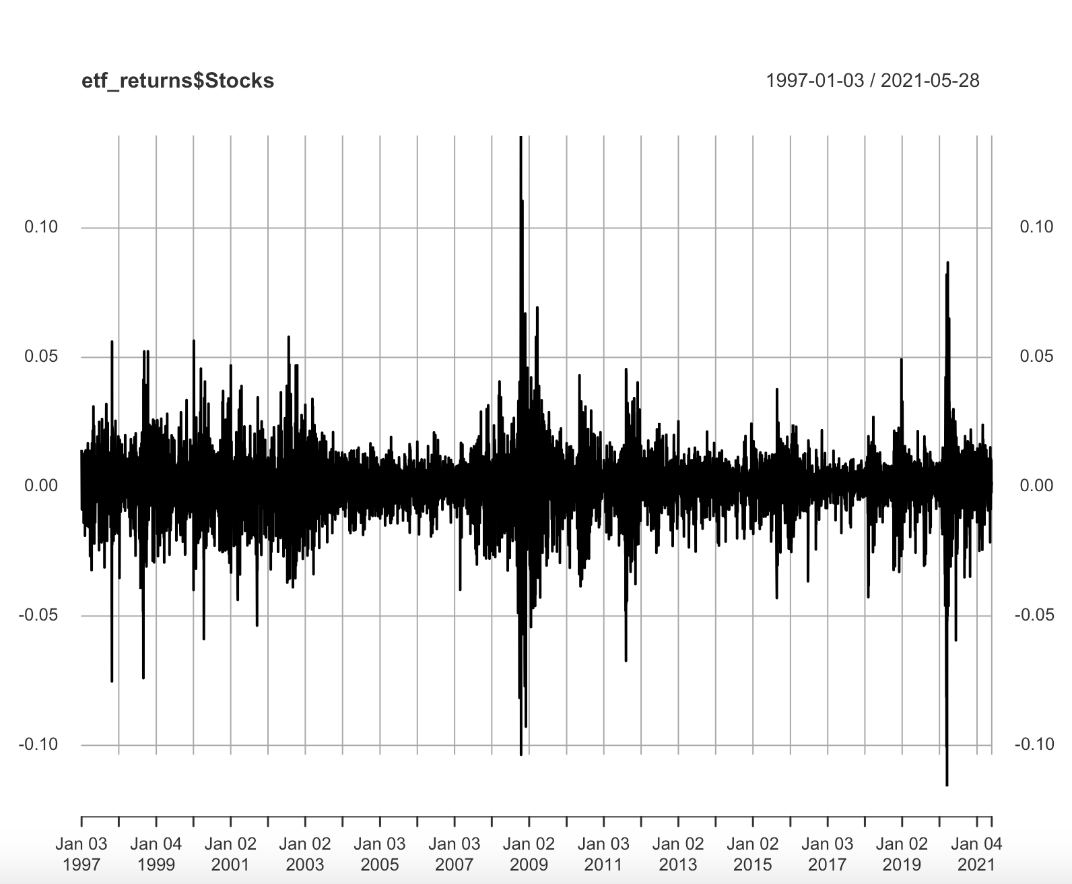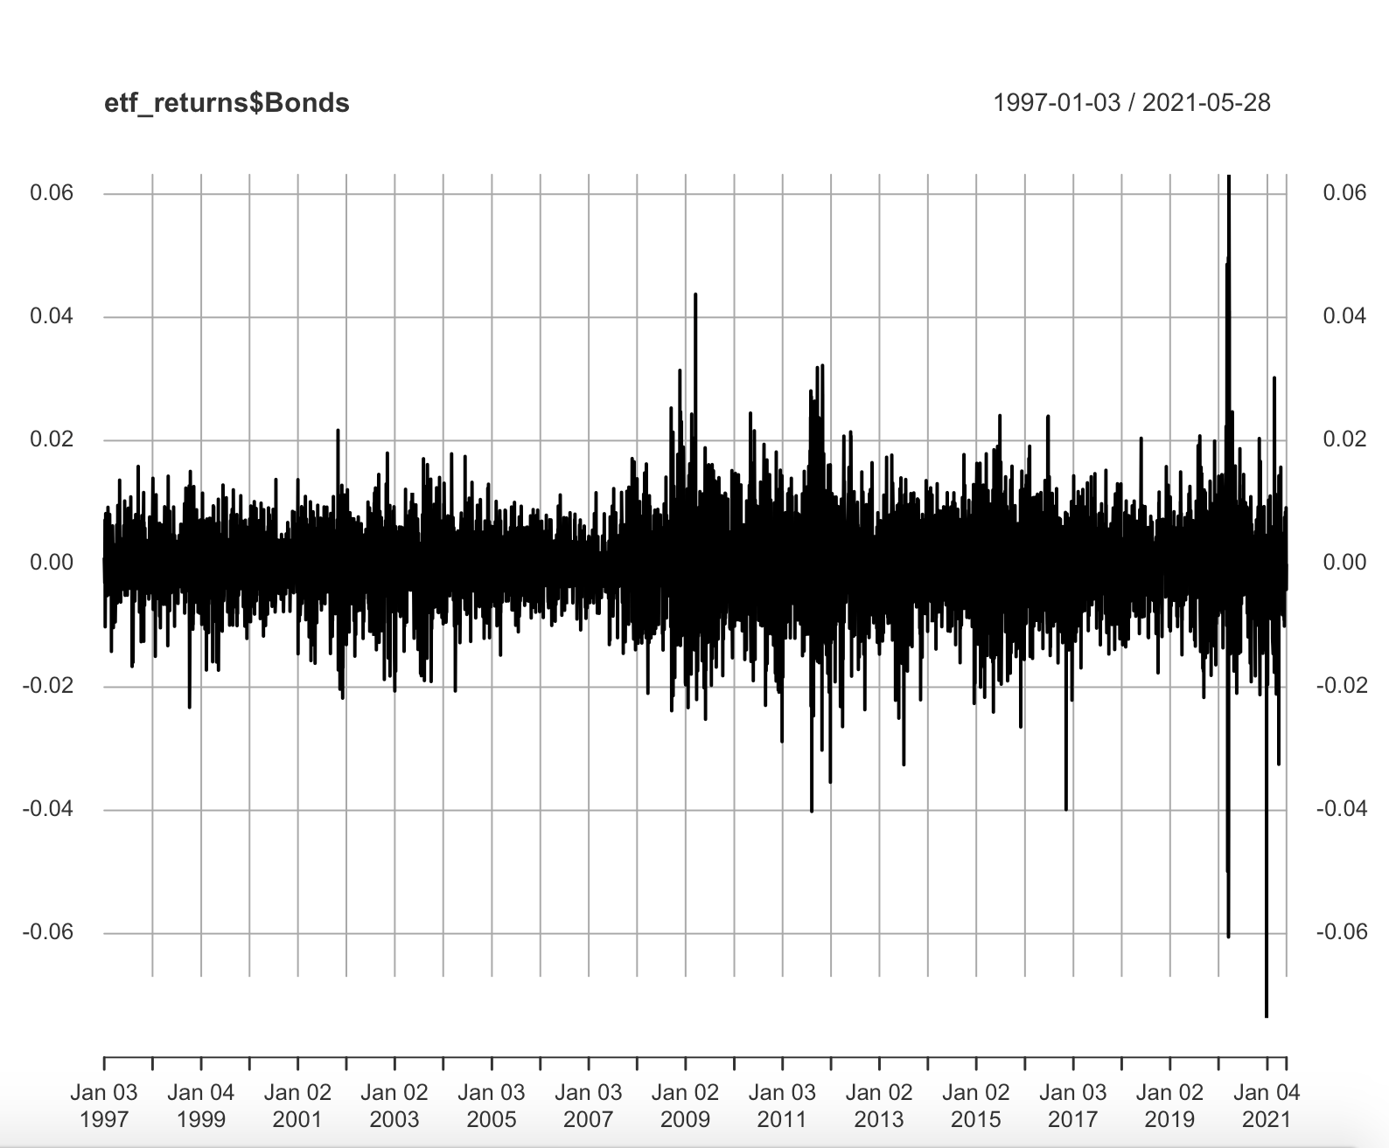

Summary of returns:

Index Bonds Stocks

Min. :1997-01-03 Min. :-7.370e-02 Min. :-0.1158865

1st Qu.:2003-02-11 1st Qu.:-3.934e-03 1st Qu.:-0.0049942

Median :2009-03-18 Median : 0.000e+00 Median : 0.0006367

Mean :2009-03-17 Mean : 3.296e-05 Mean : 0.0002826

3rd Qu.:2015-04-23 3rd Qu.: 4.254e-03 3rd Qu.: 0.0062146

Max. :2021-05-28 Max. : 6.316e-02 Max. : 0.1355773

Standard deviation of bonds and stocks:

Bonds: [1] 0.007219298

Stocks: [1] 0.01253943

Correlation between Bonds and Stocks

Bonds Stocks

Bonds 1.00 -0.32

Stocks -0.32 1.00

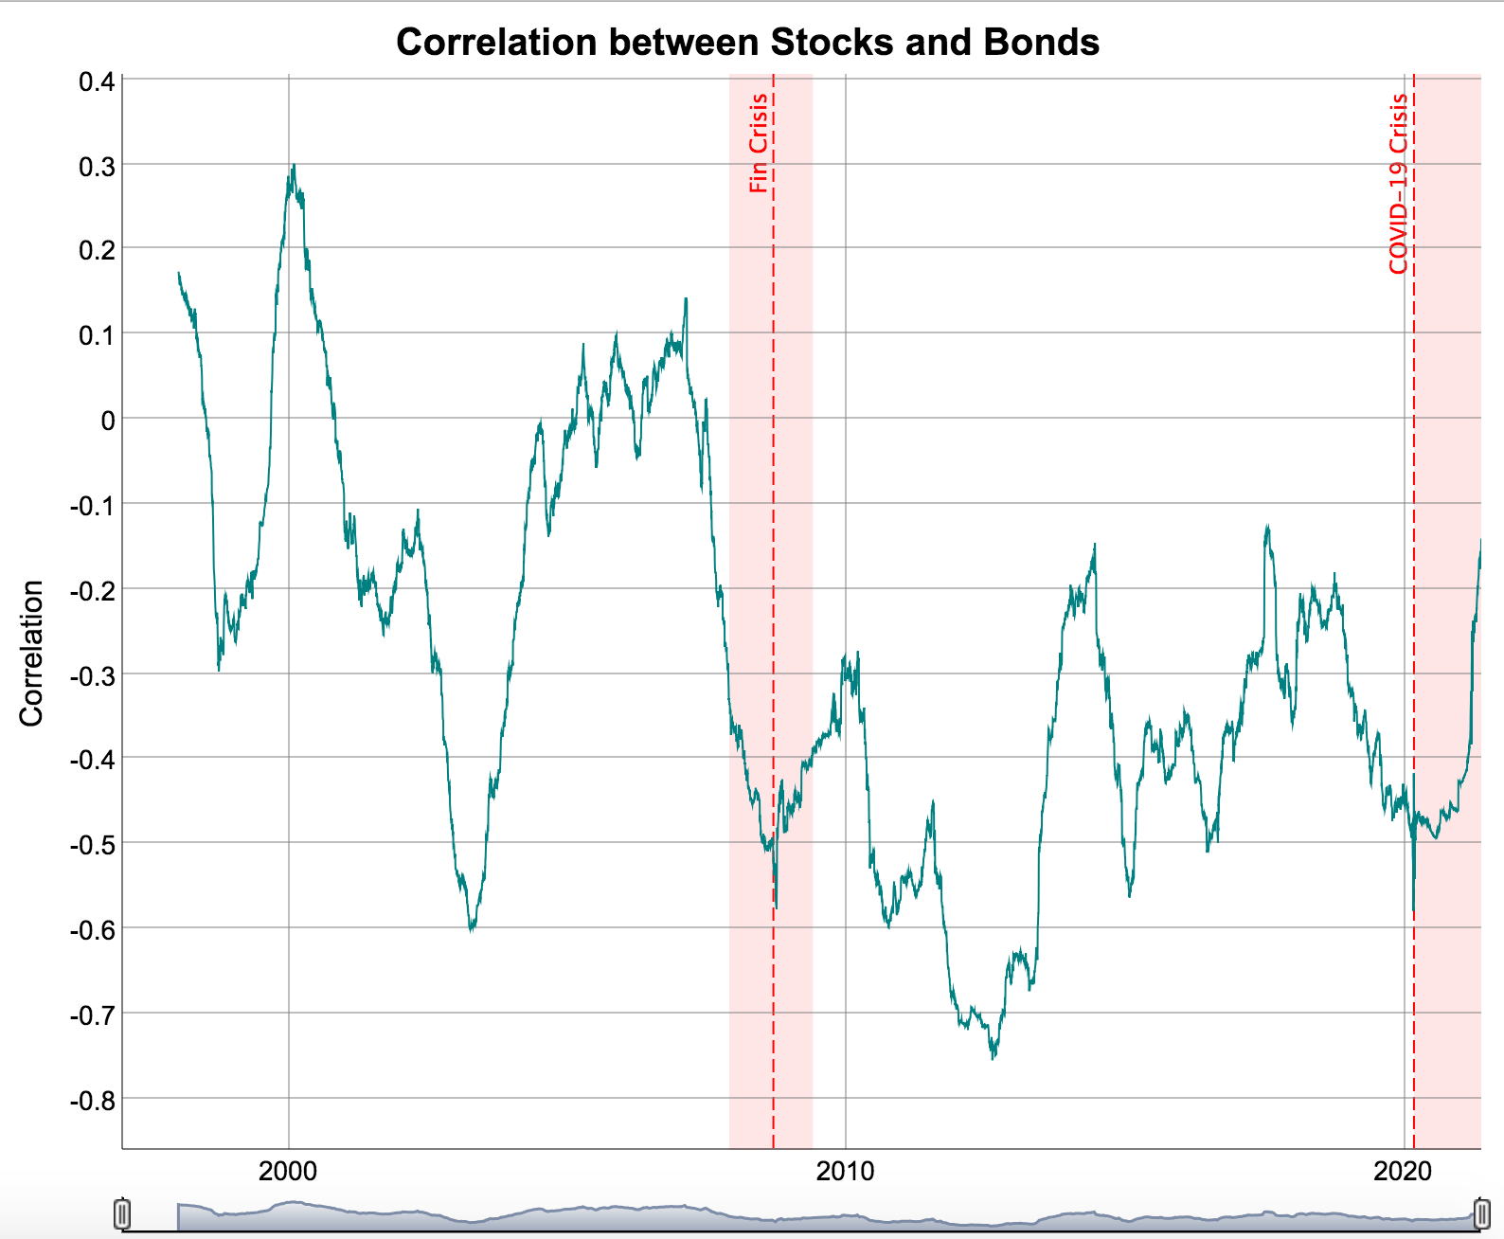

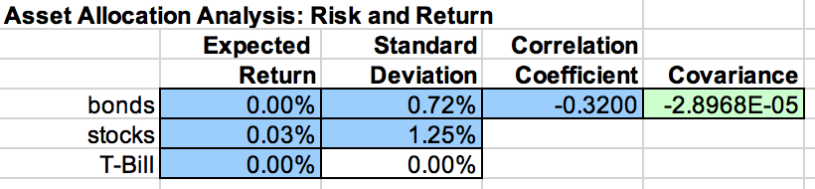

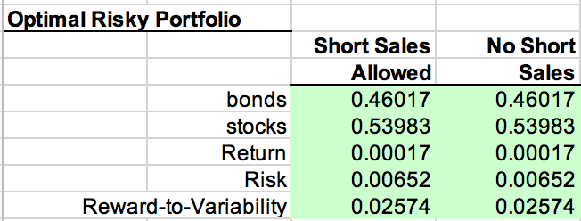

The sensitivity could be understood by security's returns to Reward-to-variability, which actually is the sharpe Ratio. The values are respectively -0.19022, -0.19021, -0.11677, -0.08842. The numerical characteristics of this portfolio change and this in my view results from the basic economic situation in different times.

The study of Sharpe ratio in modern investment theory shows that the magnitude of risk plays a fundamental role in determining the performance of the portfolio. The risk-adjusted rate of return is a comprehensive indicator that can simultaneously consider both benefits and risks, in order to eliminate the adverse effects of risk factors on performance evaluation. The calculation of the Sharpe Ratio is very simple. You can get the Fund’s Sharpe Ratio by subtracting the risk-free interest rate from the average of the fund’s equity growth rate and dividing by the standard deviation of the fund’s equity growth rate. It reflects the extent to which the growth rate of unit risk fund net value exceeds the risk-free rate of return. If the Sharpe ratio is positive, it means that the average growth rate of the fund’s net worth during the measurement period exceeds the risk-free interest rate. If the bank deposit interest rate during the same period is used as the risk-free interest rate, it means that investment funds are better than bank deposits. The larger the Sharpe ratio, the higher the risk return obtained by the risk of the fund unit.

It can be seen from the comparison that, first of all, for the two types of assets, the reward-to-variability is negative. This shows that the average net value growth rate of these two assets during the measurement period is lower than the risk-free interest rate, which is obviously bad news for investment. Specifically, for this measurement indicator, the performance of the two is similar in the period of time when there is no economic crisis. In the face of an economic crisis, bonds perform better than stocks. This is because during the economic crisis, the economic situation is turbulent and the asset market fluctuates frequently. At this time, bonds are relatively more stable than stocks because they are not a direct manifestation of fluctuating market prices. Therefore, during the economic crisis, from the value of sensitivity and the reasons behind it, bond sensitivity is better than stock. In a period of non-special economic crisis, this is the same.

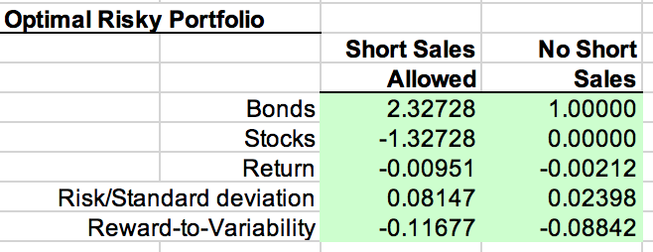



There are three recessions that we could observe and give advice to investors.

First recession: March and November 2001

During the recession from March to November of 2001, the summary of the data gives us the mean expected return and for the bonds is 0.0001164, for the stocks is -0.00188. The standard deviation for bonds is 0.01469756, for stocks is 0.03467888. The correlation coefficient between stocks and bonds is -0.06 which shows they are negatively correlated and the combination would reduce risk. Also, just look at the graph, stocks and bonds have similar fluctuations. After plug in all the numbers into Markowitz spreadsheet. The optimal risky portfolio shows that bonds weighted -0.25774, and stocks weighted 1.25774 and the expected return is -0.239% with risk and standard deviation 0.04401. Here is a strange phenomena during the recession that the investors invest a negative proportion on bonds which because the expected return for stocks is negative. The expected return becomes negative when investors invest more on stocks during the recession.

Head of 6 returns

Bonds Stocks

2001-03-09 0.004539272 -0.002024538

2001-03-16 0.009914457 -0.070087819

2001-03-23 -0.003593894 -0.004618937

2001-03-30 -0.018165804 0.019120702

2001-04-06 0.004572482 -0.029481668

2001-04-12 -0.020277192 0.047822982

summary

Index Bonds Stocks

Min. :2001-03-09 Min. :-0.0528757 Min. :-0.123341

1st Qu.:2001-05-14 1st Qu.:-0.0068152 1st Qu.:-0.018589

Median :2001-07-20 Median : 0.0045393 Median :-0.002025

Mean :2001-07-19 Mean : 0.0001164 Mean :-0.001880

3rd Qu.:2001-09-24 3rd Qu.: 0.0105680 3rd Qu.: 0.019189

Max. :2001-11-29 Max. : 0.0183974 Max. : 0.071019

Standard deviation of Bonds

0.01469756

Standard deviation of Stocks

0.03467888

Correlation between Bonds and Stocks

Bonds Stocks

Bonds 1.00 -0.06

Stocks -0.06 1.00

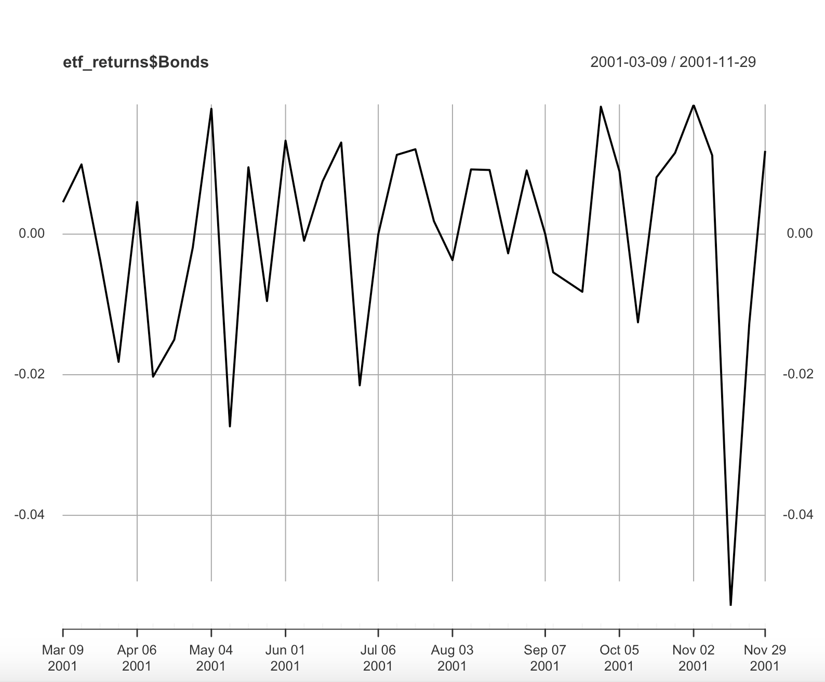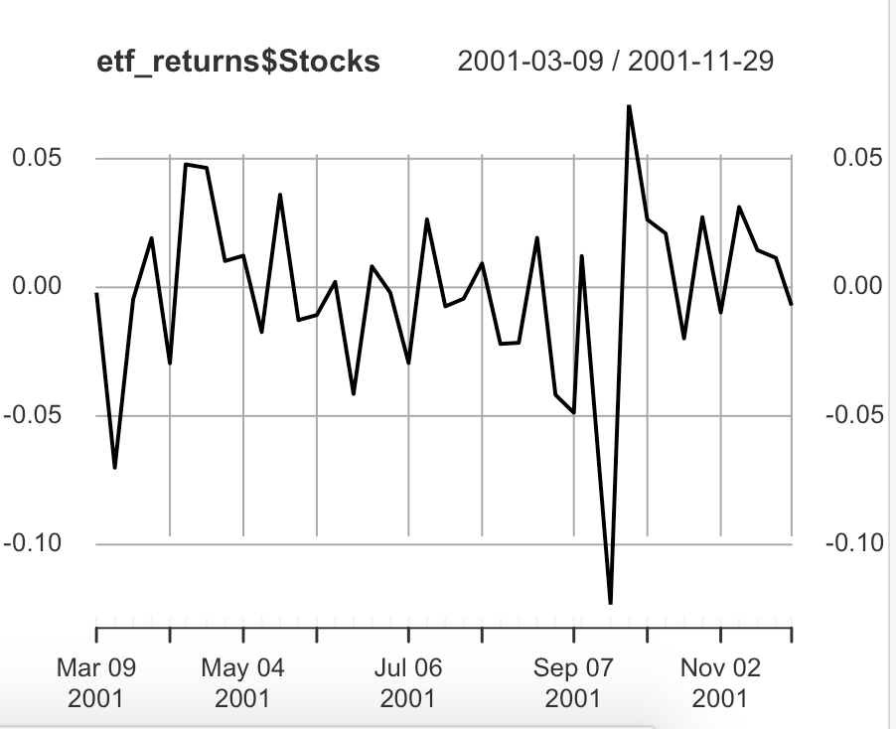

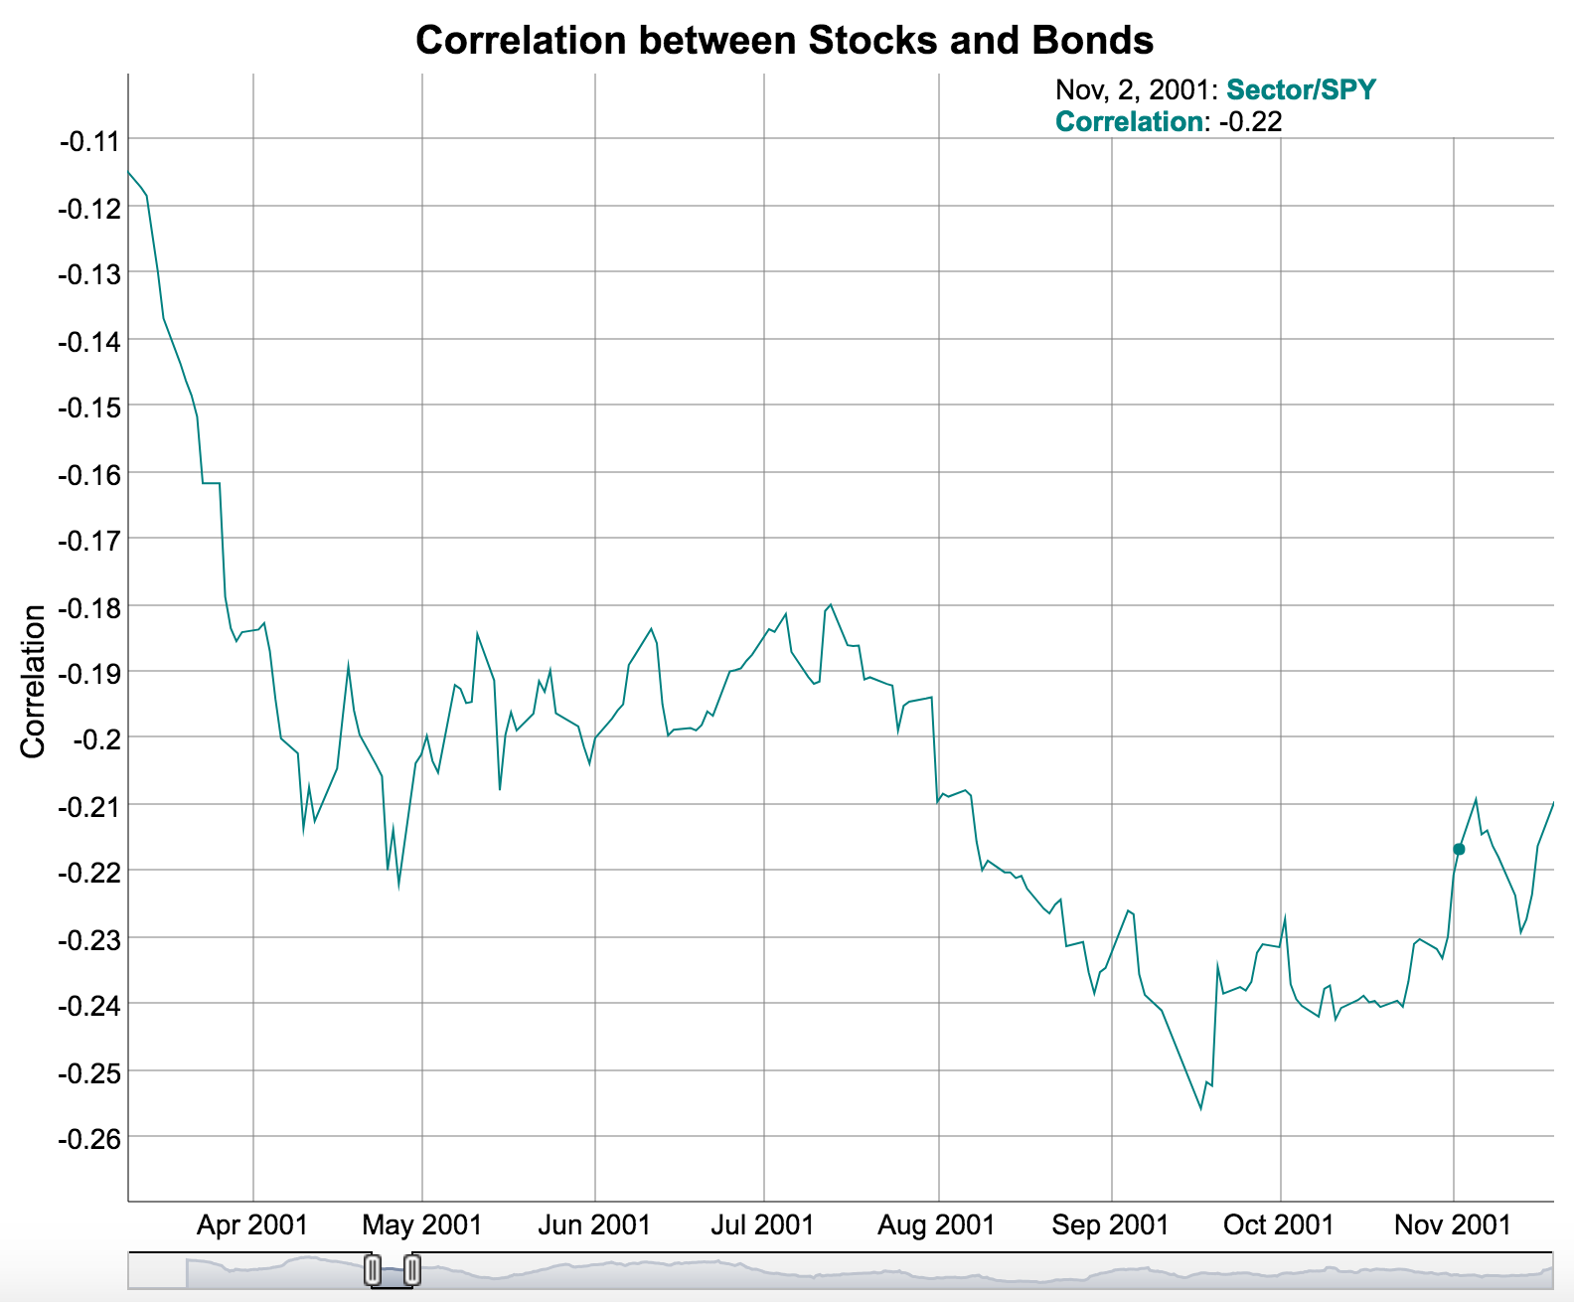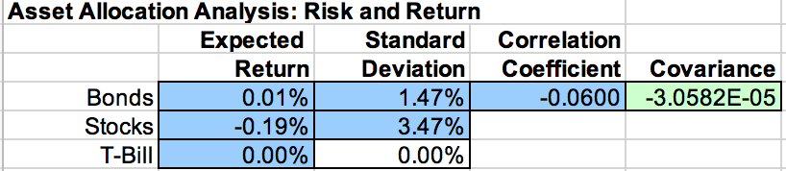

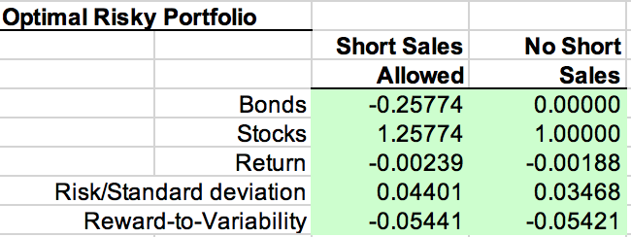

Second recession: December 2007 and March 2009

During the recession from December 2007 to March 2009, the summary of the data gives us the mean expected return and for the bonds is 0.0009465, for the stocks is -0.009419. The standard deviation for bonds is 0.01921289, for stocks is 0.04951896. The correlation coefficient between stocks and bonds is -0.25 which is even lower than the last combination and the combination would reduce more risks. Then, look at the graph, stocks and bonds had a different fluctuation on October 3, 2008, December 2008 to February 2009 and bonds have a stronger fluctuation which means the expected return of bonds are more sensitive to economic changes. After plug in all the numbers into Markowitz spreadsheet. The optimal risky portfolio shows that bonds weighted -0.02542, and stocks weighted 1.02542 and the expected return is -0.968% with risk and standard deviation 0.0509. Similarly, the investment proportion on bonds and expected return becomes negative which means investors were losing profits when investing in an optimal portfolio during the recession.

Head of 6 returns

Bonds Stocks

2007-12-14 -0.009687438 -0.025095292

2007-12-21 0.008810630 0.006501933

2007-12-28 0.002628122 -0.005618957

2008-01-04 0.019922703 -0.041515299

2008-01-11 0.000000000 -0.008242810

2008-01-18 0.011935351 -0.059456885

Summary

Index Bonds Stocks

Min. :2007-12-14 Min. :-0.0491710 Min. :-0.220564

1st Qu.:2008-04-11 1st Qu.:-0.0093578 1st Qu.:-0.034142

Median :2008-08-08 Median : 0.0008745 Median :-0.008243

Mean :2008-08-07 Mean : 0.0009465 Mean :-0.009419

3rd Qu.:2008-12-05 3rd Qu.: 0.0145738 3rd Qu.: 0.013333

Max. :2009-03-30 Max. : 0.0562578 Max. : 0.124801

Standard deviation of Bonds

[1] 0.01921289

Standard deviation of Stocks

[1] 0.04951896

Correlation between Bonds and Stocks

Bonds Stocks

Bonds 1.00 -0.25

Stocks -0.25 1.00

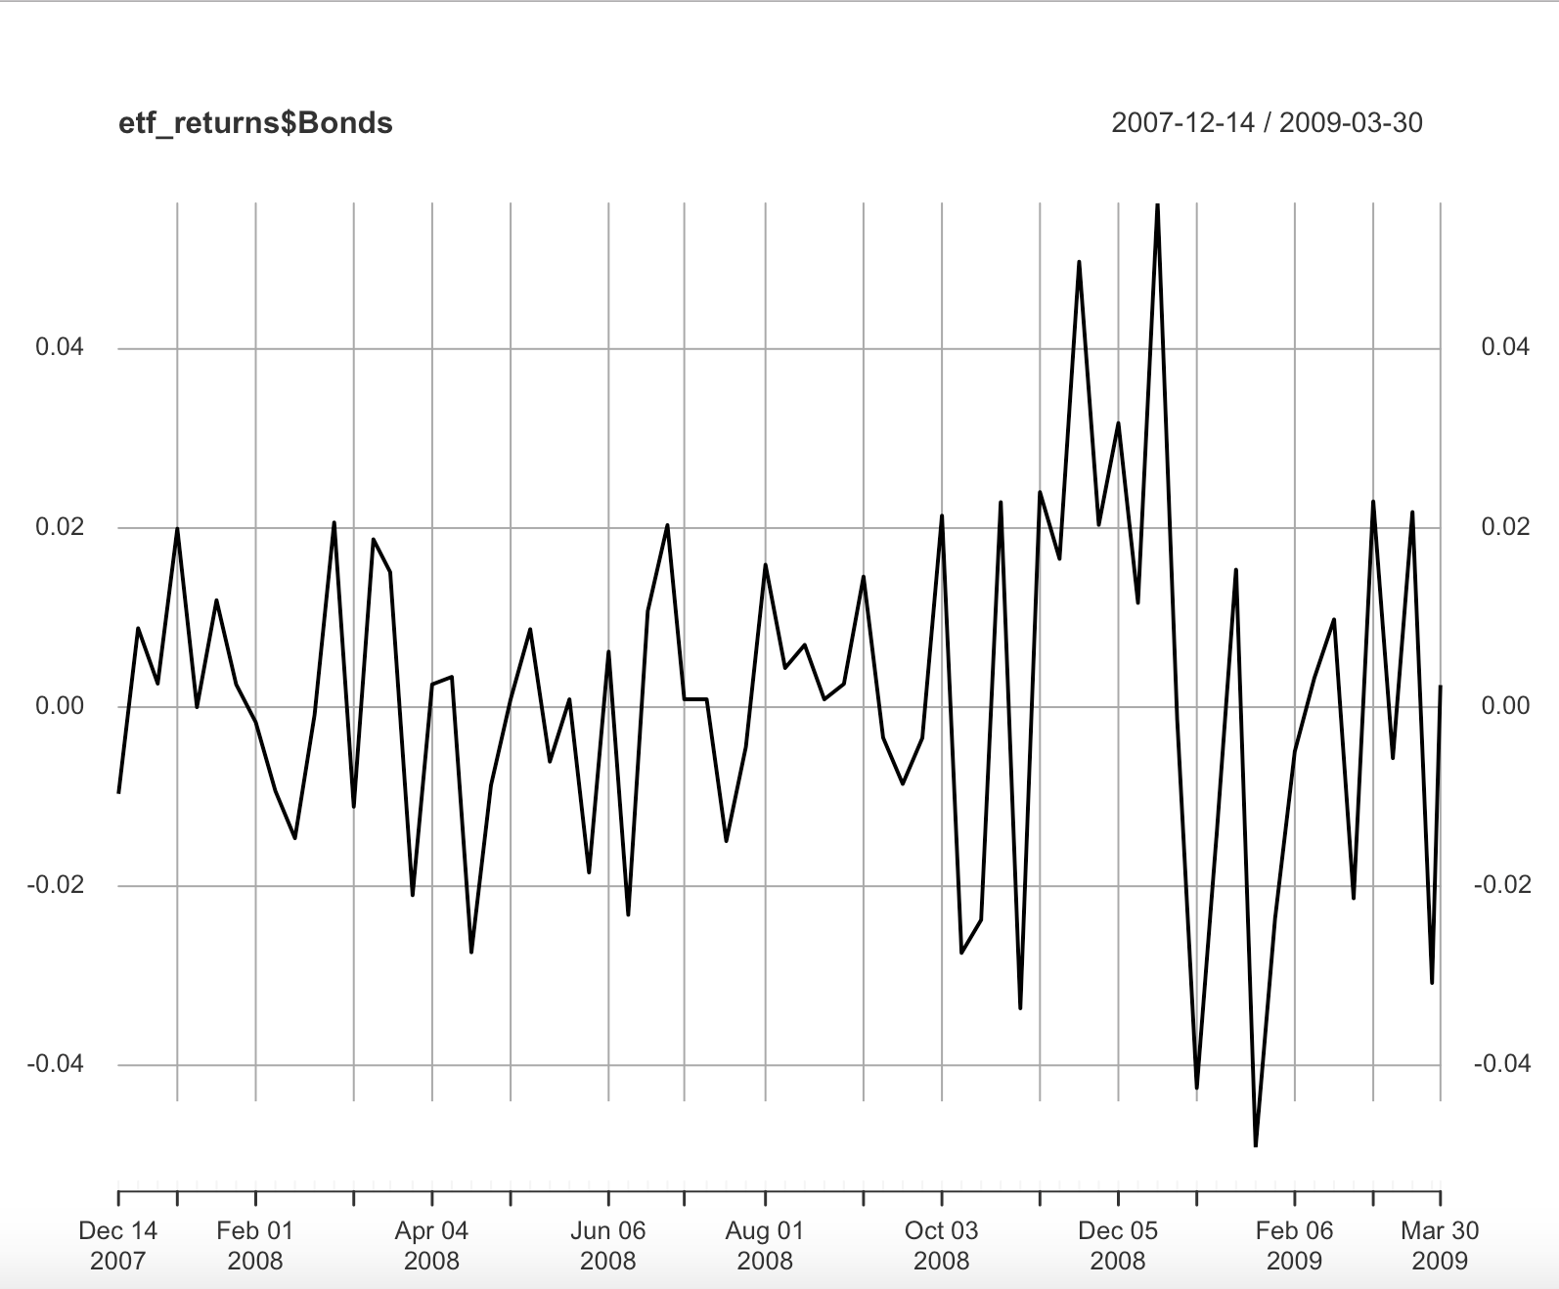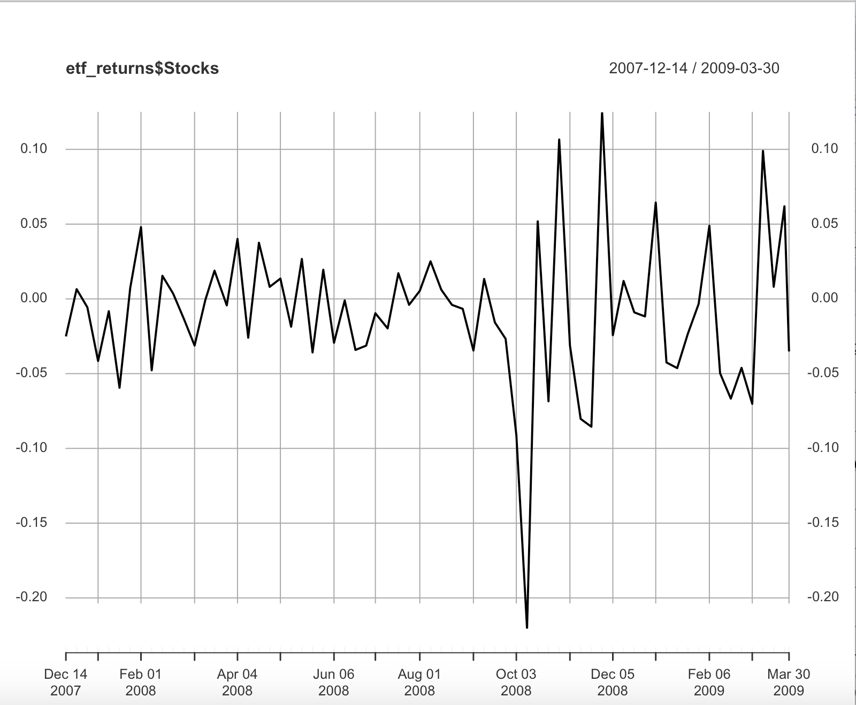

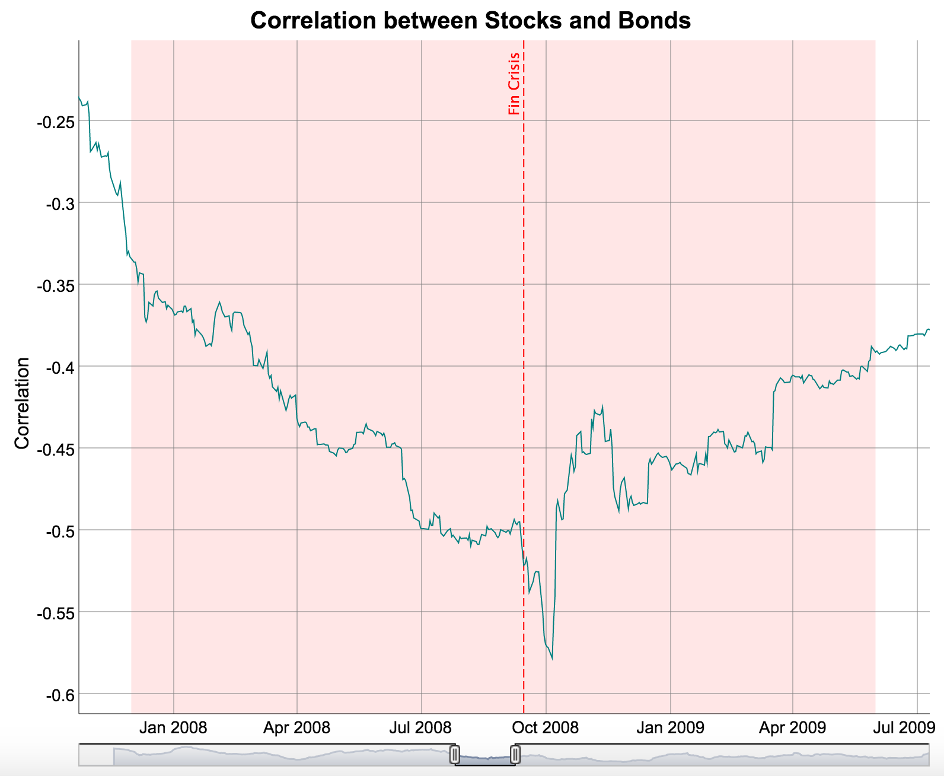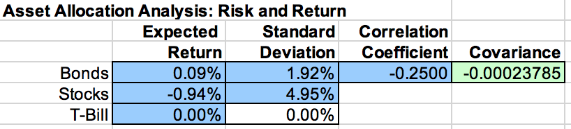

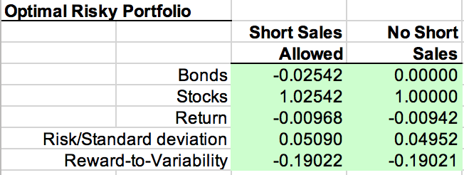

Third recession: After February 2020

The third recession began from February 2020, the summary of the data gives us the mean expected return and for the bonds is -0.00212, for the stocks is 0.00345. The standard deviation for bonds is 0.02397651, for stocks is 0.04033555. The correlation coefficient between stocks and bonds is -0.11 which is still negative and the combination would reduce risks. Look at the graph, bonds have a stronger fluctuation which also showed the expected return of bonds are more sensitive to economic changes. After plug in all the numbers into Markowitz spreadsheet. The optimal risky portfolio shows that bonds weighted 2.32728, and stocks weighted -1.32728 and the expected return is -0.951% with risk and standard deviation 0.08147. Different from the first two recession, the investment proportion on bonds is much higher, the stocks investment proportion becomes negative and both exceed one (absolute value) and expected return becomes negative hence investors are losing profits to invest in an optimal portfolio during the recession.

Head of bonds and stocks

Bonds Stocks

2020-02-14 0.000000000 0.016124547

2020-02-21 0.023413627 -0.012278854

2020-02-28 0.047252885 -0.118345446

2020-03-06 0.069126642 0.004042251

2020-03-13 -0.072476729 -0.099379442

2020-03-20 0.008686991 -0.163052017

Summary

Index Bonds Stocks

Min. :2020-02-14 Min. :-0.07248 Min. :-0.163052

1st Qu.:2020-06-10 1st Qu.:-0.01512 1st Qu.:-0.010618

Median :2020-10-05 Median : 0.00000 Median : 0.008196

Mean :2020-10-05 Mean :-0.00212 Mean : 0.003450

3rd Qu.:2021-01-30 3rd Qu.: 0.01001 3rd Qu.: 0.020266

Max. :2021-05-28 Max. : 0.06913 Max. : 0.114146

Standard deviation of Bonds

[1] 0.02397651

Standard deviation of Stocks

[1] 0.04033555

Correlation between bonds and stocks

Bonds Stocks

Bonds 1.00 -0.11

Stocks -0.11 1.00

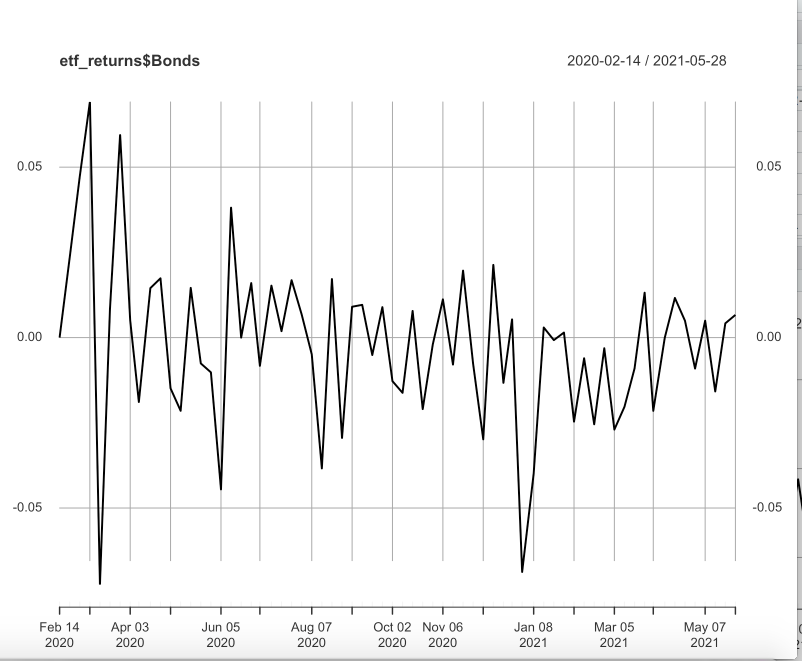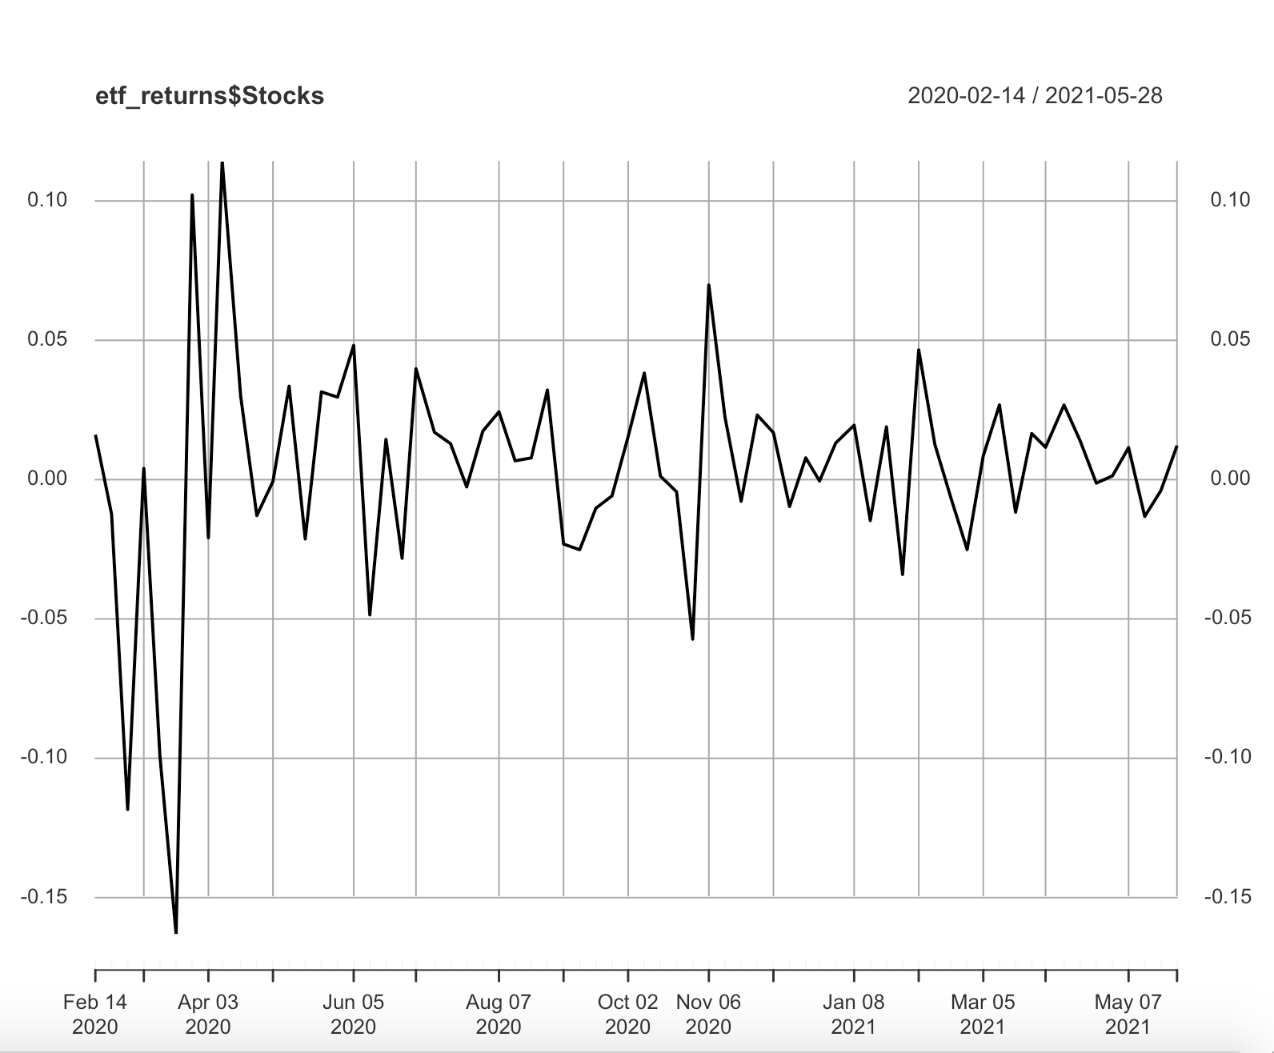

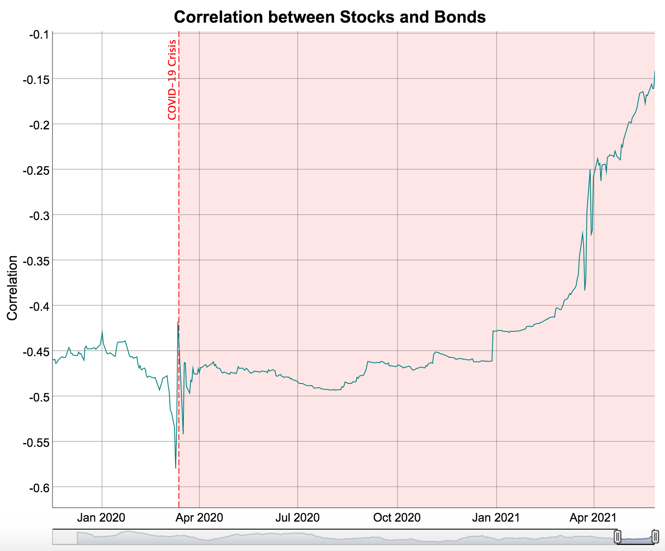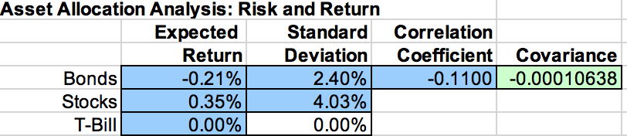



In each recession, the entire sample's portfolio has a different performance. Comparing the four recessions, it can be seen that only in the first recession is Reward-to-Variability positive, which means that only in the first recession has a positive risk-reward ratio. Secondly, in the four recessions, only the first recession still has a positive return for asset aggregation, and the next three are armchairs. From the perspective of asset allocation ratio, bond and stock in the ideal portfolio of the first recession are allocated at a ratio of about 50% each. In the second and third recessions, bond and stock are available. In short sales, the bonds are shorted and stocks are bought. When short sales are not possible, the assets are completely invested in stocks. In the fourth recession, the opposite is true. When shorting is possible, the ideal portfolio is shorting stocks, and all assets are allocated to Bonds in an asset portfolio that cannot be shorted.

First recession



Second recession



Third recession



Fourth recession



The CAPM model with formula E(ri) = rf + bi(E(rm)-r) which shows that the expected return is determined by risk-free rate, beta of the investment, and market risk premium. All the companies are experiencing the same risk-free rate and risk premium. Hence, beta determines the fluctuation of the expected return. The beta of the investment measures the risky level of the investment. If the beta is greater than one, then the stocks are riskier than the market, vice versa. My company made all the portfolio a modest 10% rate of return means we are helping investors invest into rather safer stocks with lower beta value which are more likely to guarantee the expected return. However, the rival’s company shows investors a higher return that reaches to 15% may have very large beta value and the stocks are very risky and it is not easy to get the expected returns at that high level. The more returns investors want to get, the more risk they have to take hence, investors cannot just look at the expected returns. Hence the comparison of realized returns might be flawed.

CAPM:

|  |  |  |  |
| --- | --- | --- | --- |
|  | Beta | Adjusted R^2 | Alpha |
| TSLA | 1.92749 | 0.155 | -0.01363 |
| TM | 0.82948 | 0.1455 | -0.04625 |
| GM | 1.672512 | 0.3376 | -0.05449 |

Fama-French:

|  |  |  |  |  |  |
| --- | --- | --- | --- | --- | --- |
|  | Beta | SMB | HML | Adjusted R^2 | Alpha |
| TSLA | 1.86684 | 0.67599 | -0.58304 | 0.1526 | -0.01481 |
| TM | 0.738492 | 0.049803 | 0.558663 | 0.1639 | -0.043435 |
| GM | 1.315006 | 0.918056 | 1.12137 | 0.4426 | -0.046862 |

We build tables to allow us to analyze more conveniently. All of the data are from December 01, 2010.

The concept of alpha tell that, alpha = rp - [rf - β (rm - rf)]  
Since the prevailing risk-free rate was 0%, the expected market return was 8%, your company’s portfolio returns’ sensitivity to the market was 1, and your client’s consistently portfolio returns’ sensitivity to the market was 2, the alpha of my company should be,   
 alpha = 0.1 - [0 + 1(0.08- 0)] = 0.02  
While the alpha of other companies should be,

alpha = 0.15 - [0 + 2(0.08- 0)] = -0.01

Since the alpha of my company is larger than the other, hence my company has a better performance.

It is not possible that my performance last year was pure luck rather than skill. Since I know my portfolio is always constructed in such a way and I know some firm-specific risk remaining in it which means I know the fluctuations of the beta of the companies and hence know when the stocks are likely to go up. By CAPM, I know the beta determines the companies’ performance and expected returns. Also, I know the type of the stocks that if beta greater than one, then the stock is a cyclical stock and are more likely to be influenced by economic factors and economic cycles. If the company has beta less than one, then the stock is a defensive stock and is less likely to be influenced by economic cycles such as economic recession and economic expansion. Hence, by my skills, I know when to buy and sell stocks. For example, I can buy some defensive stocks when the pandemic breaks out since I know the pandemic would lower the price of the stocks at the beginning of the pandemic. However, as time passes, the stocks are defensive which means the stocks will not be seriously influenced by the crisis and will recover quickly. Hence, after a period of time, by selling the stocks I will earn more profits. Similarly, I could buy cyclical stocks if I heard some news that would cause economic expansion such as government printing money, then I would invest more on cyclical stocks. Hence it is my skill in buying underpriced and selling overpriced stocks instead of just pure luck.

By observing the beta from CAPM we could find that Toyota has beta value less than one which means this stock is defensive. General Motors and Tesla stocks both have beta value greater than one which means these two stocks are cyclical. My answer does not change when I use the Fama-French 3 factor model because Toyota’s beta value is still less than one and General Motors and Tesla still have greater than one beta value.

According to the estimated coefficient on the SMB factor and use 0.05 as a p-value cutoff. Then, Toyota's SMB coefficient of 0.049803 is smaller than 0.05 which means Toyota is a small capitalization stock. However, Tesla and General Motors’ stocks with SMB coefficients of 0.67599 and 0.918056 respectively are greater than 0.05 means TSLA and GM stock are large capitalization stocks. The results are consistent with what I know about each company. Compared with General Motors, Toyota is a younger company since General Motors established in 1908 which is much older than Toyota. Also, Tesla developed much faster than Toyota and had higher market values than Toyota. What’s more, Toyota did not have as various products or services as General Motors and Tesla, hence the results are consistent.

According to the estimated coefficient on the HML factor and use 0.05 as a p-value cutoff. Toyota and General Motors with HML coefficients 0.558663 and 1.12137 respectively are both larger than 0.05. Hence Toyota and General Motors companies’ stocks are all value stocks since their B/M values are larger than 0.05. However, Tesla even has a negative HML coefficient -0.58304 which means it is a growth stock since it has a low B/M value. The results are consistent with what I understand about value and growth stock since compared with Toyota and General Motors, Tesla is definitely a young company and it is also a high technology company that has designed driverless cars which is the most updated technology. General Motors and Toyota are established companies that derive their returns from existing assets and hence the results are consistent with what I understand.

The p-value for each CAPM regression model is smaller than 0.05 and hence I believe the CAPM model or each asset is significant. From the table we could know that the alpha for TSLA, TM, GM are respectively -0.01363, -0.04625, -0.05449. Hence the Tesla has a better performance than a well-diversified portfolio.

By observing the Fama-French table, it shows that Tesla still has the highest alpha value and hence the result will not change.

For the R-squared, the GM has the largest Adjusted R^2 value, then the TSLA, TM. Based on the R-squared, the GM model predicts the returns best while the TM predicts the returns worst since a larger Adjusted R^2 means the model could explain the variation of the stock better. Most companies experience higher adjusted R^2 values on Fama-French models than CAPM models since they analyze more variables such as HML and SMB. However, I think there is still scope for improving the models since not all the factors Beta, SMB, HML are significant in the regression model. For example, in the TM ~ MKT_RF + SMB + HML model, the p-value for the SMB is 0.8754441, which is not significant. Hence it will be better to make a regression TM ~ MKT_RF + HML and to delete the insignificant variable.

Call:

lm(formula = TSLA ~ MKT_RF, data = ff_assets)

Residuals:

Min 1Q Median 3Q Max

-0.43593 -0.10303 -0.01393 0.08950 0.77037

Coefficients:

Estimate Std. Error t value Pr(>|t|)

(Intercept) -0.01363 0.01681 -0.811 0.419

MKT_RF 1.92749 0.39704 4.855 3.61e-06 ***

---

Signif. codes: 0 ‘***’ 0.001 ‘**’ 0.01 ‘*’ 0.05 ‘.’ 0.1 ‘ ’ 1

Residual standard error: 0.1796 on 122 degrees of freedom

Multiple R-squared: 0.1619, Adjusted R-squared: 0.155

F-statistic: 23.57 on 1 and 122 DF, p-value: 3.611e-06

Call:

lm(formula = TSLA ~ MKT_RF + SMB + HML, data = ff_assets)

Residuals:

Min 1Q Median 3Q Max

-0.45187 -0.09726 -0.00519 0.09023 0.77724

Coefficients:

Estimate Std. Error t value Pr(>|t|)

(Intercept) -0.01481 0.01713 -0.864 0.389

MKT_RF 1.86684 0.43084 4.333 3.07e-05 ***

SMB 0.67599 0.71391 0.947 0.346

HML -0.58304 0.59635 -0.978 0.330

---

Signif. codes: 0 ‘***’ 0.001 ‘**’ 0.01 ‘*’ 0.05 ‘.’ 0.1 ‘ ’ 1

Residual standard error: 0.1798 on 120 degrees of freedom

Multiple R-squared: 0.1733, Adjusted R-squared: 0.1526

F-statistic: 8.386 on 3 and 120 DF, p-value: 4.171e-05

Call:

lm(formula = TM ~ MKT_RF, data = ff_assets)

Residuals:

Min 1Q Median 3Q Max

-0.20114 -0.04548 0.01102 0.05829 0.16648

Coefficients:

Estimate Std. Error t value Pr(>|t|)

(Intercept) -0.046250 0.007499 -6.167 9.33e-09 ***

MKT_RF 0.829480 0.177077 4.684 7.36e-06 ***

---

Signif. codes: 0 ‘***’ 0.001 ‘**’ 0.01 ‘*’ 0.05 ‘.’ 0.1 ‘ ’ 1

Residual standard error: 0.08009 on 122 degrees of freedom

Multiple R-squared: 0.1524, Adjusted R-squared: 0.1455

F-statistic: 21.94 on 1 and 122 DF, p-value: 7.363e-06

Call:

lm(formula = TM ~ MKT_RF + SMB + HML, data = ff_assets)

Residuals:

Min 1Q Median 3Q Max

-0.17950 -0.04937 0.01227 0.05503 0.16331

Coefficients:

Estimate Std. Error t value Pr(>|t|)

(Intercept) -0.043435 0.007548 -5.754 6.8e-08 ***

MKT_RF 0.738492 0.189798 3.891 0.000164 ***

SMB 0.049803 0.314499 0.158 0.874441

HML 0.558663 0.262708 2.127 0.035506 *

---

Signif. codes: 0 ‘***’ 0.001 ‘**’ 0.01 ‘*’ 0.05 ‘.’ 0.1 ‘ ’ 1

Residual standard error: 0.07922 on 120 degrees of freedom

Multiple R-squared: 0.1843, Adjusted R-squared: 0.1639

F-statistic: 9.04 on 3 and 120 DF, p-value: 1.917e-05

Call:

lm(formula = GM ~ MKT_RF, data = ff_assets)

Residuals:

Min 1Q Median 3Q Max

-0.21211 -0.06702 0.01253 0.06024 0.27209

Coefficients:

Estimate Std. Error t value Pr(>|t|)

(Intercept) -0.054490 0.008876 -6.139 1.07e-08 ***

MKT_RF 1.672512 0.209597 7.980 9.07e-13 ***

---

Signif. codes: 0 ‘***’ 0.001 ‘**’ 0.01 ‘*’ 0.05 ‘.’ 0.1 ‘ ’ 1

Residual standard error: 0.0948 on 122 degrees of freedom

Multiple R-squared: 0.3429, Adjusted R-squared: 0.3376

F-statistic: 63.68 on 1 and 122 DF, p-value: 9.073e-13

Call:

lm(formula = GM ~ MKT_RF + SMB + HML, data = ff_assets)

Residuals:

Min 1Q Median 3Q Max

-0.19756 -0.06035 0.01141 0.05735 0.16639

Coefficients:

Estimate Std. Error t value Pr(>|t|)

(Intercept) -0.046862 0.008285 -5.656 1.07e-07 ***

MKT_RF 1.315006 0.208329 6.312 4.81e-09 ***

SMB 0.918056 0.345206 2.659 0.008896 **

HML 1.121370 0.288358 3.889 0.000166 ***

---

Signif. codes: 0 ‘***’ 0.001 ‘**’ 0.01 ‘*’ 0.05 ‘.’ 0.1 ‘ ’ 1

Residual standard error: 0.08695 on 120 degrees of freedom

Multiple R-squared: 0.4562, Adjusted R-squared: 0.4426

F-statistic: 33.56 on 3 and 120 DF, p-value: 8.001e-16

R Appendix:

#Finance final project code

#part 1 code

library(tidyquant)

library(tidyverse)

library(dygraphs)

##### preliminaries

ticker <- c("VUSTX", "SPY")

sector <- c("Bonds", "Stocks")

etf_ticker_sector <- data_frame(ticker, sector)

etf_ticker_sector <- tibble(ticker, sector)

##### a function that we will use to get prices from Yahoo Finance and turn them into returns

etf_weekly_returns <- function(ticker) {

prices <-

getSymbols(ticker, src = 'yahoo',

from = "1997-01-01",

to = "2021-05-31",

auto.assign = TRUE, warnings = FALSE) %>%

map(~Cl(get(.))) %>%

reduce(merge) %>%

`colnames<-`(ticker)

prices_period <- to.period(prices, period = "days", OHLC = FALSE)

# get monthly log returns

returns <-na.omit(ROC(prices_period, 1, type = "continuous"))

# change date format

#index(returns) <- as.Date(as.yearmon(index(returns), format = '%Y%m'))

#Change the column names to the sector names from our dataframe above.

colnames(returns) <- etf_ticker_sector$sector returns}

##### let's now use that function on our tickers

etf_returns <- etf_weekly_returns(etf_ticker_sector$ticker)

head(etf_returns)

##### visualizing returns

plot(etf_returns$Stocks)

plot(etf_returns$Bonds)

##### visualizing returns

hist(etf_returns$Stocks,breaks=100)

hist(etf_returns$Bonds,breaks=100)

summary(etf_returns)

sd(etf_returns$Bonds)

sd(etf_returns$Stocks)

##### correlations across the whole sample

### eliminating time index from the FFp data

etf_returns_nodate <- fortify.zoo(etf_returns)

etf_returns_nodate <- etf_returns_nodate[,c("Bonds", "Stocks")]

res <- cor(etf_returns_nodate)

round(res, 2)

######### Scatter Plots

#pairs(~Consumer_Discretionary+Consumer_Staples+Energy+Financials+Health_Care+Industrials+Materials+Information_Technology+Utilities+Market,data=etf_returns_nodate,main="Simple Scatterplot Matrix")

plot(etf_returns_nodate$Bonds, etf_returns_nodate$Stocks)

abline(reg = lm( etf_returns_nodate$Stocks ~ etf_returns_nodate$Bonds), col = "red", lwd = 2)

#Stocks vs Bonds over time

correlation <- function(returns, window) {

merged_xts <- merge(returns, etf_returns$Stocks)

merged_xts$rolling_test <- rollapply(merged_xts, window,

function(x) cor(x[,1], x[,2],

use = "pairwise.complete.obs"),

by.column = FALSE)

names(merged_xts) <- c("Sector Returns", "SPY Returns", "Sector/SPY Correlation")

merged_xts}

Bonds_Stocks_correlation <- correlation(etf_returns$Bonds, 260)

dygraph(Bonds_Stocks_correlation$'Sector/SPY Correlation', main = "Correlation between Stocks and Bonds") %>%

dyAxis("y", label = "Correlation") %>%

dyRangeSelector(height = 20) %>%

dyShading(from = "2020-03-13", to = "2021-05-31", color = "#FFE6E6") %>%

dyEvent(x = "2020-03-13", label = "COVID-19 Crisis", labelLoc = "top", color = "red") %>%

dyShading(from = "2007-12-01", to = "2009-06-01", color = "#FFE6E6") %>%

dyEvent(x = "2008-09-15", label = "Fin Crisis", labelLoc = "top", color = "red")

#first recession

##### preliminaries

ticker <- c("VUSTX", "SPY")

sector <- c("Bonds", "Stocks")

etf_ticker_sector <- data_frame(ticker, sector)

etf_ticker_sector <- tibble(ticker, sector)

##### a function that we will use to get prices from Yahoo Finance and turn them into returns

etf_weekly_returns <- function(ticker) {

prices <-

getSymbols(ticker, src = 'yahoo',

from = "2001-03-01",

to = "2001-11-30",

auto.assign = TRUE, warnings = FALSE) %>%

map(~Cl(get(.))) %>%

reduce(merge) %>%

`colnames<-`(ticker)

prices_period <- to.period(prices, period = "week", OHLC = FALSE)

# get monthly log returns

returns <-na.omit(ROC(prices_period, 1, type = "continuous"))

# change date format

#index(returns) <- as.Date(as.yearmon(index(returns), format = '%Y%m'))

#Change the column names to the sector names from our dataframe above.

colnames(returns) <- etf_ticker_sector$sector

returns}

##### let's now use that function on our tickers

etf_returns <- etf_weekly_returns(etf_ticker_sector$ticker)

head(etf_returns)

##### visualizing returns

plot(etf_returns$Stocks)

plot(etf_returns$Bonds)

#summary and standard deviation

summary(etf_returns)

sd(etf_returns$Bonds)

sd(etf_returns$Stocks)

##### correlations across the whole sample

### eliminating time index from the FFp data

etf_returns_nodate <- fortify.zoo(etf_returns)

etf_returns_nodate <- etf_returns_nodate[,c("Bonds", "Stocks")]

res <- cor(etf_returns_nodate)

round(res, 2)

correlation <- function(returns, window) {

merged_xts <- merge(returns, etf_returns$Stocks)

merged_xts$rolling_test <- rollapply(merged_xts, window, function(x) cor(x[,1], x[,2],

use = "pairwise.complete.obs"), by.column = FALSE) names(merged_xts) <- c("Sector Returns", "SPY Returns", "Sector/SPY Correlation") merged_xts}

Bonds_Stocks_correlation <- correlation(etf_returns$Bonds, 260)

dygraph(Bonds_Stocks_correlation$'Sector/SPY Correlation', main = "Correlation between Stocks and Bonds") %>%

dyAxis("y", label = "Correlation") %>%

dyRangeSelector(height = 20) %>%

dyShading(from = "2020-03-13", to = "2021-05-31", color = "#FFE6E6") %>%

dyEvent(x = "2020-03-13", label = "COVID-19 Crisis", labelLoc = "top", color = "red") %>%

dyShading(from = "2007-12-01", to = "2009-06-01", color = "#FFE6E6") %>%

dyEvent(x = "2008-09-15", label = "Fin Crisis", labelLoc = "top", color = "red")

#Second recesion

##### a function that we will use to get prices from Yahoo Finance and turn them into returns

etf_weekly_returns <- function(ticker) {

prices <-

getSymbols(ticker, src = 'yahoo',

from = "2007-12-01",

to = "2009-03-31",

auto.assign = TRUE, warnings = FALSE) %>%

map(~Cl(get(.))) %>%

reduce(merge) %>%

`colnames<-`(ticker)

prices_period <- to.period(prices, period = "week", OHLC = FALSE)

# get monthly log returns

returns <-na.omit(ROC(prices_period, 1, type = "continuous"))

# change date format

#index(returns) <- as.Date(as.yearmon(index(returns), format = '%Y%m'))

#Change the column names to the sector names from our dataframe above.

colnames(returns) <- etf_ticker_sector$sector

returns}

##### let's now use that function on our tickers

etf_returns <- etf_weekly_returns(etf_ticker_sector$ticker)

head(etf_returns)

##### visualizing returns

plot(etf_returns$Stocks)

plot(etf_returns$Bonds)

#summary and standard deviation

summary(etf_returns)

sd(etf_returns$Bonds)

sd(etf_returns$Stocks)

##### correlations across the whole sample

### eliminating time index from the FFp data

etf_returns_nodate <- fortify.zoo(etf_returns)

etf_returns_nodate <- etf_returns_nodate[,c("Bonds", "Stocks")]

res <- cor(etf_returns_nodate)

round(res, 2)

#Third recesion

##### a function that we will use to get prices from Yahoo Finance and turn them into returns

etf_weekly_returns <- function(ticker) {

prices <-

getSymbols(ticker, src = 'yahoo',

from = "2020-02-01",

to = "2021-05-31",

auto.assign = TRUE, warnings = FALSE) %>%

map(~Cl(get(.))) %>%

reduce(merge) %>%

`colnames<-`(ticker)

prices_period <- to.period(prices, period = "week", OHLC = FALSE)

# get monthly log returns

returns <-na.omit(ROC(prices_period, 1, type = "continuous"))

# change date format

#index(returns) <- as.Date(as.yearmon(index(returns), format = '%Y%m'))

#Change the column names to the sector names from our dataframe above.

colnames(returns) <- etf_ticker_sector$sector

returns}

##### let's now use that function on our tickers

etf_returns <- etf_weekly_returns(etf_ticker_sector$ticker)

head(etf_returns)

##### visualizing returns

plot(etf_returns$Stocks)

plot(etf_returns$Bonds)

#summary and standard deviation

summary(etf_returns)

sd(etf_returns$Bonds)

sd(etf_returns$Stocks)

##### correlations across the whole sample

### eliminating time index from the FFp data

etf_returns_nodate <- fortify.zoo(etf_returns)

etf_returns_nodate <- etf_returns_nodate[,c("Bonds", "Stocks")]

res <- cor(etf_returns_nodate)

round(res, 2)

#Part 2 code:

library(tidyverse)

library(lubridate)

library(xts)

library(zoo)

library(quantmod)

library(tidyr)

library(dplyr)

library(broom)

library(ggplot2)

library(tibbletime)

library(fpp2)

library(tidyquant)

library(dygraphs)

################# loading the factors to R from the local drive; formatting the date; throwing out observation with missing date

FF <- read_csv("~/Desktop/financial economics/Week 6/F-F_Research_Data_Factors.CSV",

skip = 3) %>% rename(date = X1) %>% mutate(date = ymd(parse_date_time(date, "%Y%m"))) %>% na.omit(date)

################# transforming FF into a long format for ggplot

FF_long <-

FF %>%

select(-RF) %>%

gather(factor, returns, -date)

################# cumulative returns of the HML factor

FF_HML <- FF %>% select(date, HML) %>% mutate(HML = HML/100)

port_cumulative_ret <- FF_HML %>%

mutate(cr = cumprod(1 + HML))

port_cumulative_ret %>%

ggplot(aes(x = date, y = cr)) +

geom_line() +

labs(x = 'Date',

y = 'Cumulative Returns',

title = 'Portfolio Cumulative Returns') +

theme_classic() +

scale_y_continuous(breaks = seq(1,100,5)) +

scale_x_date(date_breaks = 'month',

date_labels = '%Y') + theme(axis.text.x = element_text(angle = 90))

#STOCKS

################# pulling stock data straight from Yahoo Finance

symbols <- c("TSLA","TM","GM")

prices <-

getSymbols(symbols, src = 'yahoo',

from = "2010-12-01",

auto.assign = TRUE,

warnings = FALSE) %>%

map(~Ad(get(.))) %>%

reduce(merge) %>%

`colnames<-`(symbols)

################# converting the price date into monthly returns

returns <-

prices %>%

to.monthly(indexAt = "firstof", OHLC = FALSE) %>%

# convert the index to a date

data.frame(date = index(.)) %>%

# now remove the index because it got converted to row names

remove_rownames() %>%

# convert from wide to long creating new variable asset that will assign ticker, conversion needed to create returns using lagged variables

gather(asset,prices,-date) %>%

# compute returns using the usual way

group_by(asset) %>%

mutate(returns=(prices/lag(prices))-1) %>%

# remove prices

select(-prices) %>%

# convert back to wide by asset

spread(asset, returns) %>%

# remove missings

na.omit()

head(prices,10)

returns_df <- as.data.frame(returns)

head(returns_df,10)

#3 FACTOR MODELS

##################### merging asset returns with factors, and converting returns to excess returns

ff_assets <-

returns %>%

left_join(FF, by = "date") %>%

mutate(MKT_RF = `Mkt-RF`/100,

SMB = SMB/100,

HML = HML/100,

TSLA = TSLA-RF,

TM = TM-RF,

GM = GM-RF) %>%

select(-RF,-`Mkt-RF`) %>%

na.omit()

#Tesla

## estimating CAPM model

capm_TSLA <- lm(TSLA ~ MKT_RF,data=ff_assets)

summary(capm_TSLA)

## estimating 3 factor model

ff3_TSLA <- lm(TSLA ~ MKT_RF + SMB + HML,data=ff_assets)

summary(ff3_TSLA)

#Toyota

## estimating CAPM model

capm_TM <- lm(TM ~ MKT_RF,data=ff_assets)

summary(capm_TM)

## estimating 3 factor model

ff3_TM <- lm(TM ~ MKT_RF + SMB + HML,data=ff_assets)

summary(ff3_TM)

#General Motors

## estimating CAPM model

capm_GM <- lm(GM ~ MKT_RF,data=ff_assets)

summary(capm_GM)

## estimating 3 factor model

ff3_GM <- lm(GM ~ MKT_RF + SMB + HML,data=ff_assets)

summary(ff3_GM)